Best Five Pitching Projects

No.1 Anti-Troy

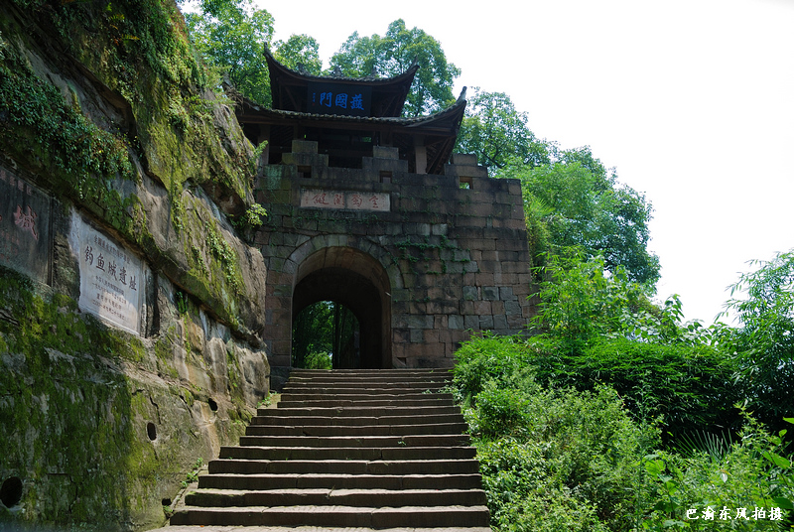

Company Name: Documentary Media, Chongqing Broadcasting & TV
Program Title: Anti-Troy
Applicant: Ms. XU Bei
Address: 159 3rd Zhongshan Lu, Chongqing, China 400039
Mobile: 13908337244
Email: xubei125@163.com

Brief Resume of Applicant
Xu Bei is a producer of the Documentary Media, Chongqing Broadcasting Group.

Her main works are Xi Xiaoyu, which was awarded the second prize of 2004 China Television Broadcasting and News Award, and On Her Way Downtown-A Story about Chen Xiaomei, which was awarded the first prize of the Chinese Rainbow Award, Golden Eagle’s “Excellent Documentary” and the first prize of the Starlight Cup Award. Her work Going to Town won several top prizes of China, and was invited to screen at Manchester Anthropological Film Festival and St. Petersburg Festival. In 2008, she produced a feature film Dead End which was given a top mark at Film Channel.

Length of the program (minute): 90
Key Location: Chongqing/Inner Mongolia
Duration: 12months
Budget (USD): 1.5million
Equipment: Red one

Introduction of Content
Built in 13th century which was the late Southern Song Dynasty in Chinese history, Fishing City (Diaoyu Cheng) is one historic site of ancient battlefields in eastern suburb in Hechuan District, Chongqing City, southwest of China. During that time, the Mongolian army was invading towards the inland areas in the southern China. In order to fight against the Mongol armies, a series of constructions similar to the European medieval castle fortress were successively conducted in Sichuan Province, southwest of China. Fishing City was one of the strongest castles.

No. 2 Chinese Alligator

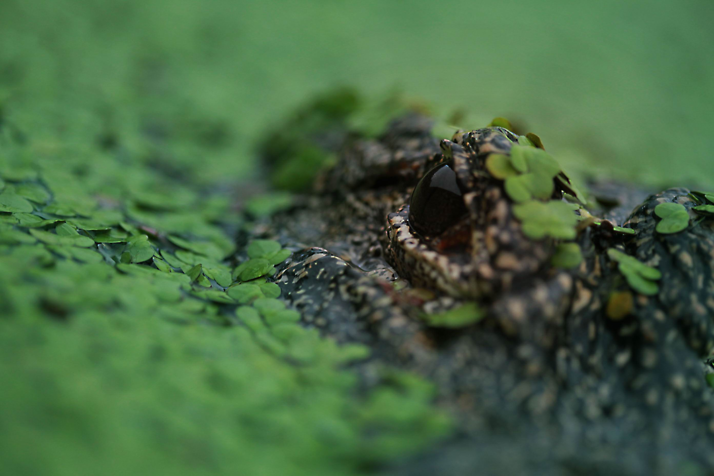

Company Name: Shanghai Science & Technology Museum
Program Title: Chinese Alligator
Applicant: Mr. WANG Xiaoming
Address： 2000 Century Avenue, Pudong New District, Shanghai China， 200127
Mobile: 13916752551
Email: wangxm@sstm.org.cn; xmwang@ecnu.edu.cn

Brief Resume of Applicant
Director-General of Shanghai Science & Technology Museum and doctoral supervisor in biology, former Vice-President of East China Normal University, who raised the idea to shoot a series of Chinese endangered species while cultivating a team of this regard. He had hosted over 20 provincial-level projects and projects internationally funded by NIH, WCS, FFI etc. and many of his findings and papers had filled in international blanks. In 2010, as a co-writer, his book Chinese Alligator were published by Johns Hopskins University Press. In 2010, the first film Chinese Giant Salamander were shooted and broadcasted in the DocuChannel and reached an audience rating at 0.5%, ranking the 4th of that day, 0.3% higher than the average. His way of combining Chinese culture and art into science has got high comments from many fields.

Length of the program (minute): 30
Key Location: Anhui Xuancheng, Changxing
Duration: 10/06-11/06

Introduction of Content
The Chinese Alligator is a unique species of China amongst the world endangered reptiles, ranking the first-grade State protection wild animal and only 120-150 reserved wild. The film will be divided into Habitat, Biological Characteristics, Living History, Mating behavior, Reproduction, Cave Inside, Eating Habit, History Retrospect, Link with Chinese Dragon—Origin with Chinese Traditional Culture, Status-Quo and Protection, etc. The film will be live-action mainly, to wait and catch the scenes. We’ll basically take “jump-cutting” method and use super-length lens to shoot the scenes such as “building nest”, “laying eggs”, “protection of eggs” and “prey-catching” etc. We’ll also adopt infrared photography technology to ensure the authenticity in timing and the accuracy of the micro part. We’ll use wash-painting method, 3D animation, microphotography, and macrophotography that the live-action shooting is hard to reach.

No. 3 Wild Ducks Have a Home

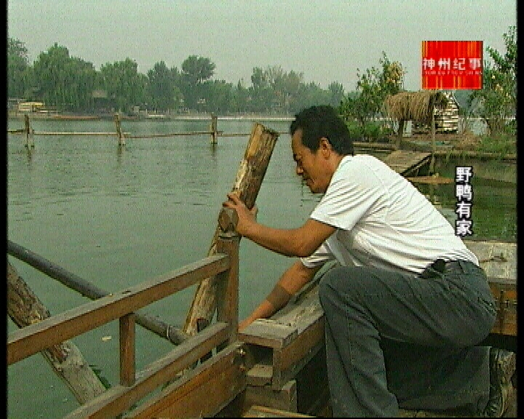

Company Name: Overseas Program Center, Beijing TV
Program Title: Wild Ducks Have a Home
Applicant: Mr. LI Zi
Address: Jia No. 98, Jianguo Road, Chaoyang District, Beijing 100022
Mobile: 13910286880
Email: lizibtv@yahoo.com.cn

Brief Resume of Applicant
Graduated from China University of Political Science and Law’s Law Dept., I am a producer of Overseas Program Center of Beijing TV. I mainly engaged in the planning and producing of documentaries. My works “The Soul with Swan”, “The Basket of Mr. Xiang”, “Wild Ducks Have a Home” and other documentaries have won the top ten documentaries of China Broadcasting & TV Association. Moreover, “The Wild Ducks Have a Home” also won the prize of winner of qualification competition at the International Festival of Nature Films in the name of the Waga Brothers in Poland in 2008. In the same year, the documentary also entered the competition of “The Green Screen” International TV Festival held in Germany and the Peninsula TV Festival

Length of the program (minute): 30
Key Location: Beijing
Duration: 12 months
Budget (USD): 80000
Equipment: HDV, SDV

Introduction of Content
This documentary is the international release version of “Wild Ducks Have a Home”. Everybody knows that wild ducks don’t have home. However, one day 10 years ago, two wild ducks flied to Beijing’s famous Shichahai Lake. This rarely-seen scene was observed by Qu Xisheng, a laid-off worker. Ten years later, the Wild Duck Island with several hundred wild ducks has become a charming scenery of Beijing. This documentary records how Qu Xisheng managed to conquered various difficulties and build up the home for wild ducks. Now he has become an environment-protection volunteer and also a wild duck expert. He has been awarded the outstanding Achievements Award for Individuals’ Education for Love Animals by IFAW in Sep. 2003. It’s the first such prize given to Chinese people. More than seven years have passed, there must have more stories worth to be recorded. Although Qu Xisheng has met more difficulties and more challenges, he never stopped and continues his career and his moving story with wild ducks.

No. 4 Life with Terracotta Army

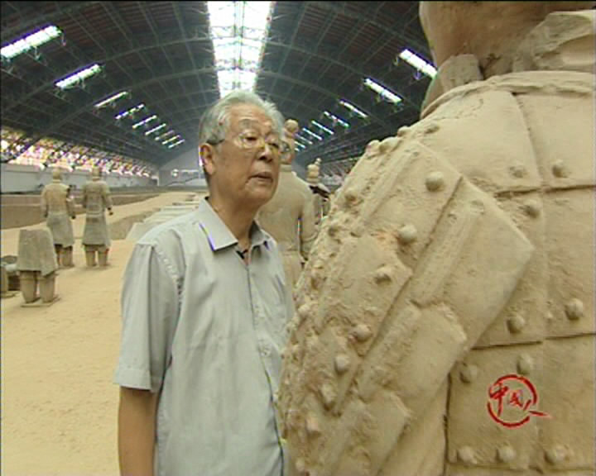
Company Name: Tianjin Television Station
Program Title: Life with Terracotta Army
Applicant: Ms. JIANG Hong
Address: No.143, Weijin Rd, Heping District, Tianjin 300070
Mobile: 13702136768
Email: T6chinese@163.com

Brief Resume of Applicant
She joined in the program of “Chinese People” of TJTV in 2004 and started my career as a producer of the documentaries. She participated in the production of documentaries about many people including Yuan Longping, He Zuoxiu, Qian Shaowu, and Liao Jingwen. The documentaries about Yuan Longping, "The Father of Hybrid Rice" and He Zuoxiu, an influential intellectual were awarded the first prize of CRTA. She also involved herself into the production of several large-scale special events, such as “Permanent Memories”, “Backbone”, which was also awarded the first prize of CRTA, “the Thirtieth Anniversary of Reform and Opening Up”, which was awarded the accessit, and “I’m a Soldier” awarded the first prize of Tianjin Broadcasting and TV Society.

Length of the program (minute): 60
Key Location: Shannxi
Duration: 7 days
Budget (USD): 80000
Equipment: Sony IMX

Introduction of Content
In 1964, Yuan Zhongyi, who has just got the master’s degree of pre-modern Chinese history of East China Normal University, got onto a train heading for the Northwest China. At that time, nobody would have thought that he would stay there for more than 40 years and become a well-known archaeologist. It was also unexpected that he would devote his life to the Terracotta Army, the most important archaeological discovery in the 20th century.

Diverse narrative spaces and suspense were introduced into the documentary, which was formed from the interviews and images according to the affective cues. The details were properly inserted into the narrative of the story and got individuated effect.

No. 5 Call from the Wild

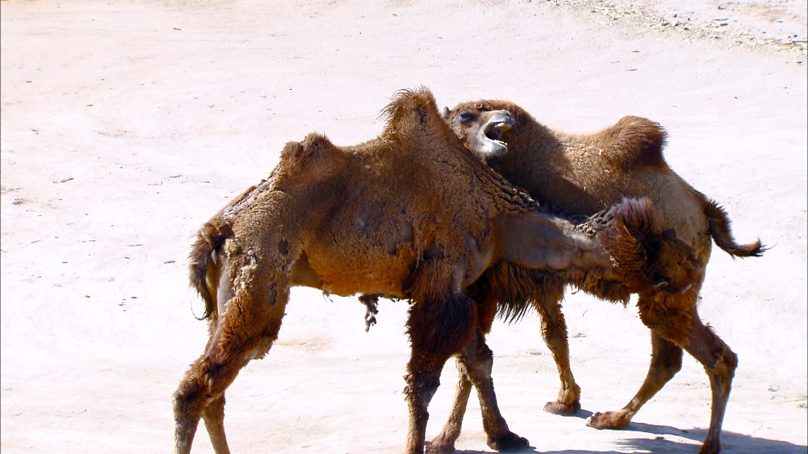

Company Name: Beijing Science & Education Film Studio
Program Title: Call from the Wild
Applicant: Ms. CUI Ying
Address: Chief editor office, No.74，North Street, Xi Cheng District, Beijing,100035
Mobile: 13621168325
Email： cuiyingmail@sina.com

Brief Resume of Applicant
Cui Ying, a director of Beijing Science Education Film Studio, has directed "Lonely Young – Story of the 263rd elk", which won China TV Golden Eagle Award in 2006 (the best long documentary award with "Forbidden City" together), planned and directed "Little Green Dragon of Mang Shan", "Millennium of Qidan", "Home", "Death of The Deer King" and other programs, which separately received China Documentary Academy Award, China TV Top Ten Documentary Award, Shen Nong Award, Science and Technology Progress Award, the Best Publication of the Year and other TV awards, and has programming experience in various types of programs, especially in wildlife, folkway and archeology.

Length of the program (minute): 30' x 10
Key Location: Tibet, Xinjiang, Qinghai, Yunnan, Jilin, Heilongjiang,Liaoning, Shaanxi, Jiangsu, Guangdong, Guangxi, Anhui, Gansu, Inner Mongolia, Hainan, Hong Kong, Fujian and so on

Introduction of Content
China has a unique wildlife resource. Out of filming permits and other issues, some animals can not have good performance. This film will fill this gap. “Call of The Wild" receives the unprecedented cooperation from China government, scientific community and the relevant non-governmental organizations and obtained a great deal of valuable materials. We have a large material proportion, almost 1:100.

“Call of The Wild" is divided into two episodes, water and land. The filming range stretches across China. Snow leopard, Siberian tiger and other species, which the world pays attention to, are included. A wide range of animals, which live in areas where foreign photographers can not get filming permit, are covered, such as camelus ferus, living in Lop Nor Desert, the nuclear launch site of China.

The program has been filmed for one year now, and it is predicted at the end of 2011 the post-production will begin after finishing the filming. At present, it is successful that HD materials of dozens of wild animals have been obtained, including recording feeding, estrus and other ecological behaviors of camelus ferus for the first time in history.

